# C:\Users\James\AppData\Local\Microsoft\Windows\INetCache\Content.Word\1510864_10152222978819882_1653651865_n.jpg

Test and Integration plan

#### Software Team, James Oatley

# Document Control

|  |  |  |  |  |
| --- | --- | --- | --- | --- |
| Version Number | Modified By | Date | Section(s) Modified | Comments |
| *1.0* | *R. Tan* | *10/03/2014* | *All* | *Document Created* |
| *1.1* | *J. Oatley* | *06/04/2014* | *All* | *Re-formatted.* |
| 1.2 | R. Tan | 07/04/2014 | All | *Testing and Integration procedure change.* |
| 1.3 | R.Tan | 03/06/2014 | 1.3 | *Integration Guidelines* |
|  |  |  |  |  |
|  |  |  |  |  |
|  |  |  |  |  |
|  |  |  |  |  |
|  |  |  |  |  |
|  |  |  |  |  |
|  |  |  |  |  |
|  |  |  |  |  |
|  |  |  |  |  |

Contents

[Document Control 1](#_Toc389561832)

[1 Test and Integration Plan 1](#_Toc389561833)

[1.1 Introduction 1](#_Toc389561834)

[1.2 Testing and Integration Plan 1](#_Toc389561835)

[1.3 Conclusion 1](#_Toc389561836)

[Appendix 2](#_Toc389561837)

[Appendix 1 2](#_Toc389561838)

# Test and Integration Plan

## 1.1 Introduction

The testing and integration phase when constructing a product will determine the final quality of the product. Hence coming up with a concrete testing and integration plan for each iteration is crucial and essential. Appendix 1 shows the flow chart on how the testing and integration plan is to be executed.

## 1.2 Testing and Integration Plan

As mentioned in the Quality Assurance Manual, testing of each feature or user stories should be taking place during its implementation phase.

However only after Iteration 1, once all individual user stories of the iteration have been tested, will integration commence. This is done so as to provide the entire group with a basic module and in further iterations, for any pair team that have finished their subsequent user stories could integrate that user stories into the basic module. An Integration Guideline Document is created to provide the employees a step by step instruction to integrate their completed user stories into the main module.

After any integration has been made to the basic module, the pair team would first have to test the integrated user story’s test class to ensure that the functionality of the newly integrated code. After having a ‘Green Bar’ meaning a pass in the Junit Test class, test the newly integrated module with the deterministic test plan so as to ensure that the integration did not break the existing product. If the newly integrated module did not achieve the pre-determined outcome of the DTP, that user story module will be removed and referred back to the pair team for further investigation.

The user story test plan used will be tailored to fit the iteration being developed. However, the iterations will follow a similar plan to that mentioned above where the module is tested as it is developed and integration testing is carried out and if any problems arise during integration, the module is removed then the code revised.

## 1.3 Conclusion

Having the testing procedure as mentioned in section above, ensures that the product being produced meets the requirement and of high quality standard. Since Spoon is following the AGILE principles, the tests inside the DTP records might change over time. Therefore, communication between the software and testing sides must be established.

# Appendix

## Appendix 1

## https://encrypted-tbn3.gstatic.com/images?q=tbn:ANd9GcQafuROGBrO9WyHtsImMUPv0jyxBTVmKH-ZU6axVf9YjQocSy_p



**User**

**Stories Completed**

**Run the Junit Test again for the integrated user story.**

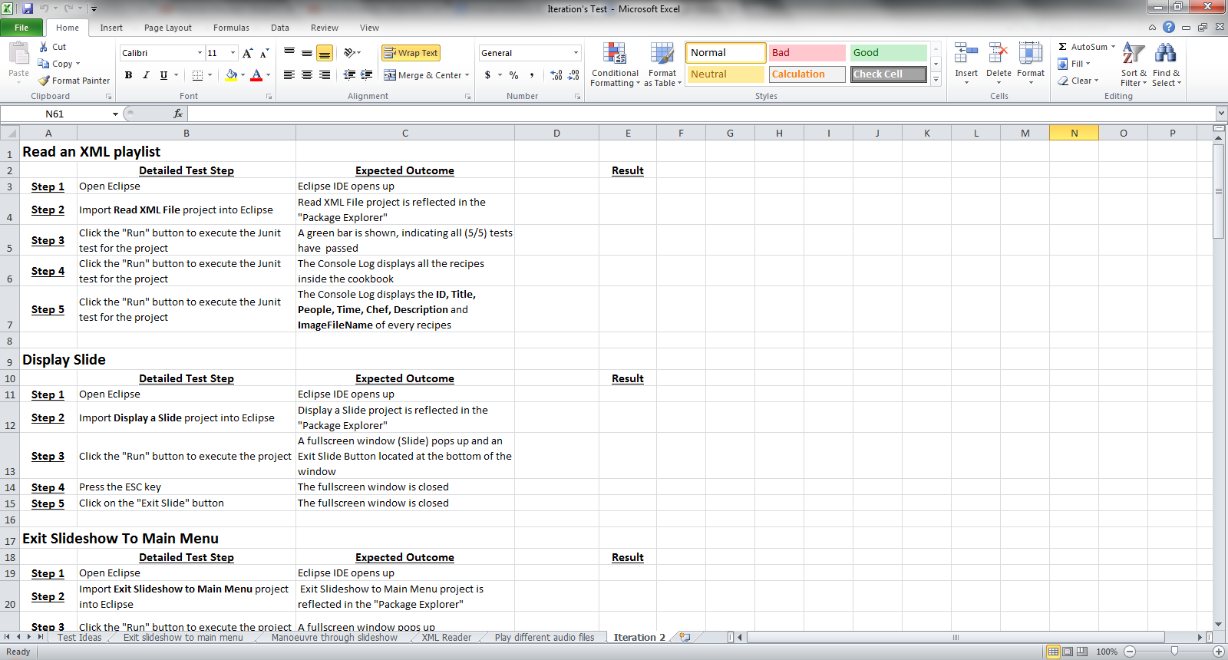

**Test the integrated module with the deterministic test plan**

**Consolidate and integrate each user stories and perform test plan according**